St. Mary the Virgin, Calverleigh

‘RESTORE THE FLOOR’

Coffee Morning

Saturday 10th May

10.00am – 12 noon
@
Calverleigh village hall

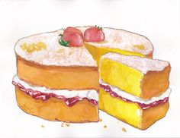
Cake stall Draw


Competitions

Bring and buy Refreshments

All proceeds will go towards the church floor repair fund

