Calverleigh village hall and St. Mary the Virgin Church

HM Queen Elizabeth II
Platinum Jubilee Celebration
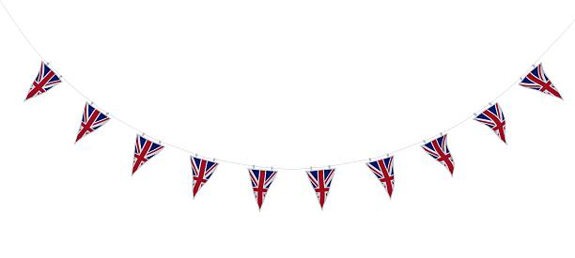

@ Calverleigh Village Hall
Saturday 4th June 2022
3.00pm – 6.00pm

Afternoon Tea
(bring and share)

Fancy Dress Competition (12 and unders)
Theme - Kings and Queens

Face painting, all age fun and games, draw
Please bring your own drinks and glasses
(tea and coffee will be provided)

Contact tattyamory@gmail.com or 07789634793
to book your place

