**St Mary the Virgin, Calverleigh**

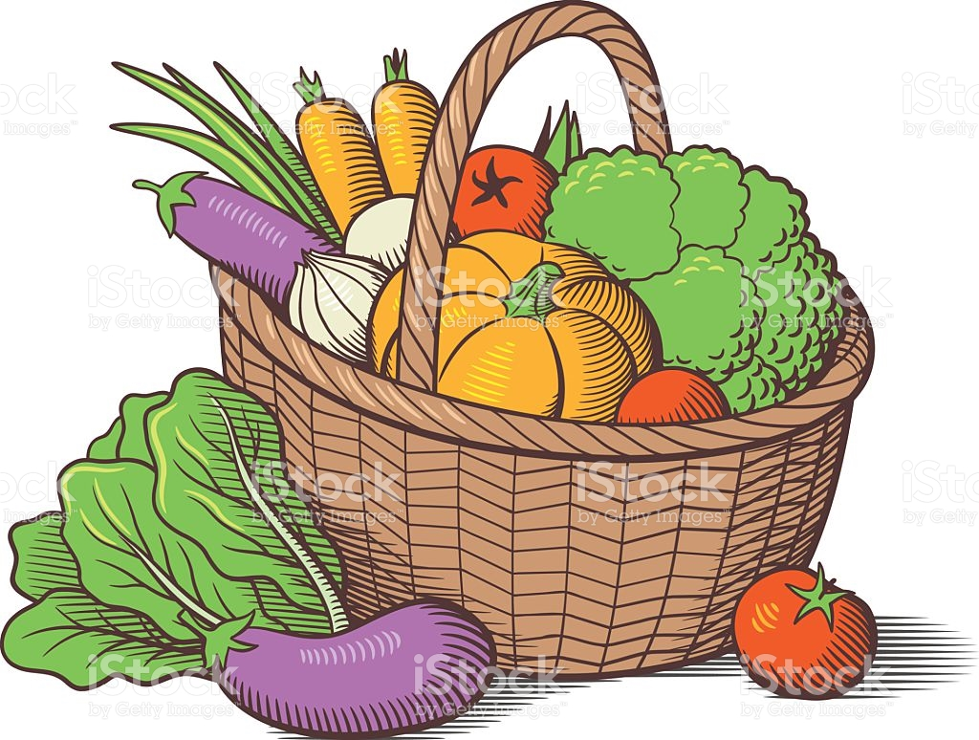

# **Harvest Supper**

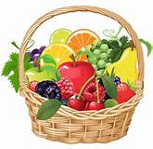

Bring and Share Supper

With tea and coffee provided

Saturday 16th September 2023

Calverleigh Village Hall at 7.30pm

Food, fellowship and a bit of fun to celebrate the season.

Please ring Aubrey on 255248

or Jackie on 255814 to book a place

Please bring your own drinks and glasses